# GGS 366: Lab 1

## General guidelines

**Please submit the .ipynb notebook containing all the codes.** Make sure the notebook is properly formatted by following the instructions below.

* Separate answers to each question using text cells and markdown headings. See example syntax here: [Markdown Guide - Colab](https://colab.research.google.com/notebooks/markdown_guide.ipynb)
* Write the essay questions in your Python notebook using text cells.
* The function body must include a docstring to provide a general description of the function.
* Each step of the code needs to be commented.
* The code needs to be properly indented and readable. For more on formatting guidelines: [PEP 8 – Style Guide for Python Code | peps.python.org](https://peps.python.org/pep-0008/) and [PEP 257 – Docstring Conventions | peps.python.org](https://peps.python.org/pep-0257/)
* See an example here:
* 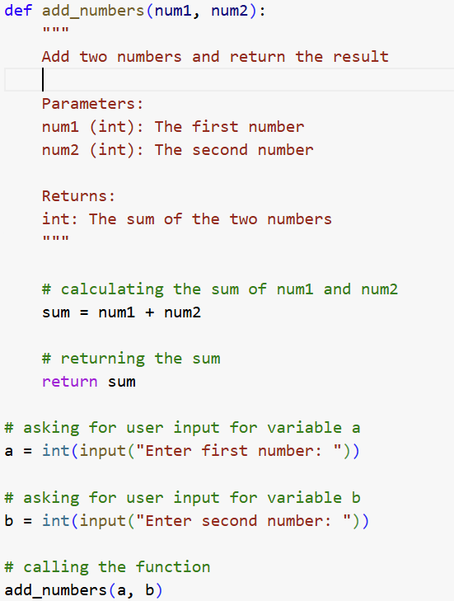

You may use GenAI as a supporting tool. However, directly copying code from GenAI will be considered plagiarism and hinder your learning process. This can negatively impact your performance in course exams and, ultimately, your professional success. Therefore, it is in your best interest to thoroughly understand the fundamental concepts and make a genuine effort to solve the problems on your own.

## Question 1

Write a Python function that prints a string statement. Using these three parameters (name, age, and city of residence), the function should print the following statement:

**"My name is [name].**

**I’m [age] years old. I live in [city] city.**

**Here’s my website link: https:\\[name].github.io"**

Use string formatting to insert the values correctly into the sentence. Call and test the function with at least three sets of arbitrary values.

## Question 2

Euclidean distance is a commonly used method for calculating the straight-line distance between two geographic locations. Given the longitude and latitude of Location 1 as (x₁, y₁) and Location 2 as (x₂, y₂), write a function to compute the Euclidean distance between them using the following formula:

Using this function, calculate the Euclidean distance between Exploratory Hall at GMU Fairfax (longitude: -77.31, latitude: 38.83) and the National Mall in Washington, DC (longitude: -77.04, latitude: 38.89).

## Question 3

Use the code from the previous question as an example to explain the concepts of function arguments and parameters.

## Question 4

Write a function kg_to_lb that converts a given weight in kilograms to pounds and returns the result. (Use the conversion: 1 kg = 2.20462 lb).

Write another function average_weight_in_lb that asks three users to provide their body weight (in kg), calculates their average weight in kg, converts it to pounds using kg_to_lb, and prints:  
**"The average weight is [average] lb."** Call and test the average_weight_in_lb function with at least three sets of arbitrary values.

## Question 5

Write a function that calculates a person's monthly commuting expense based on the daily driving distance between home and work (in kilometers), a fixed miles-per-gallon (MPG) value of 30 mpg, and a fixed gas price of $2.99 per gallon. The function should return the total monthly fuel cost for commuting. Call and test this function with at least three sets of arbitrary values. Would using a default argument value be appropriate in this case? Explain your reasoning.